Exempt Employee’s Timecard

Starting Kronos

- Enter the URL to access Kronos: https://www.kronos.utah.edu
- Select the Employee Time Entry link.
- Enter your UNID as the User Name. Be sure to use a lowercase “u”.
- Enter your password. To reset or find the default password, go to gate.acs.utah.edu
- Hit Enter or click on the Log On button.

Approve: Approves the timecard.
Time Period: Change the time frame visible.
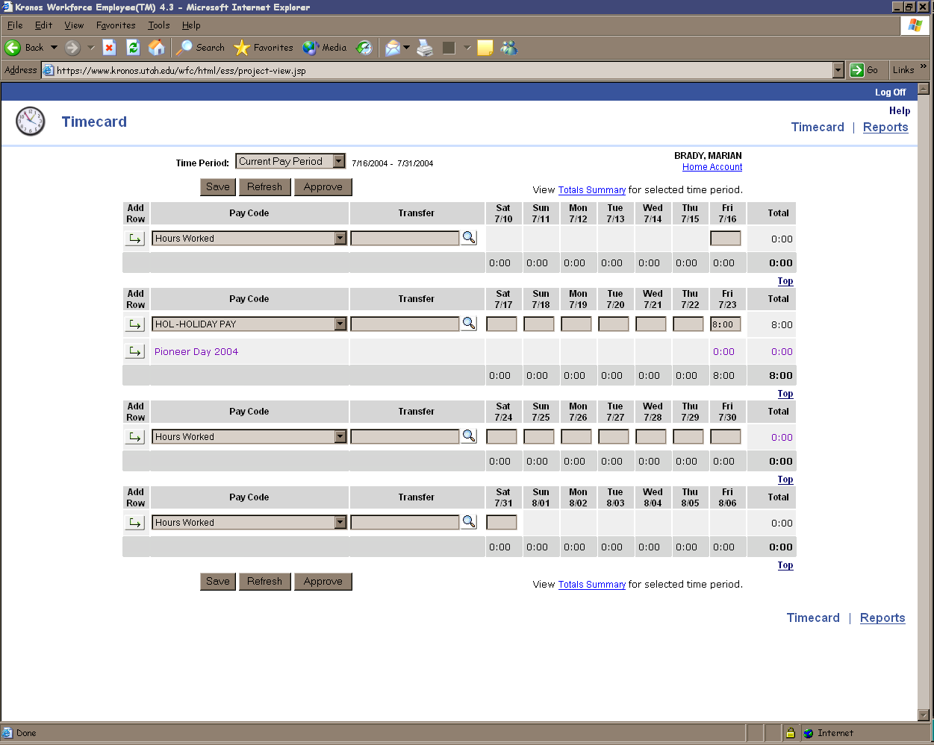
llllllllllllllllllllllllllllllllll
Pay Codes: Sick, Vacation, Holiday, etc.
Weekly Total : View Only
Daily Amounts: Enter leave time
Add Row: Inserts a new row
Reports: Employee reports
Save: Saves your changes.
Online Help
Log Off

Entering Time Off

Note: Exempt employees only enter leave time. Do not enter time worked.

- Click the down arrow in the Pay Code column, and select the appropriate leave code from the drop-down list.
- Enter the number of hours in the applicable date column.

Note: If you need to use a different Pay Code, if one is already there for the week, click the Add Row icon and then select the different code needed.

Approving Your Timecard

- Select the appropriate time period from the Time Period drop-down list.

- Click the Approve button

Removing Your Approval

- Click the Remove Approval button.
- Review the message and click ok.
Note: You cannot remove your approval if your manager has approved or signed off your timecard.

Generating Reports

- Click on the Reports link at the top of the page.
- Select a report.

- Select the Time Period and enter specific dates if required.
- Click View Report.
- To print a report, click the Print button on the browser toolbar.

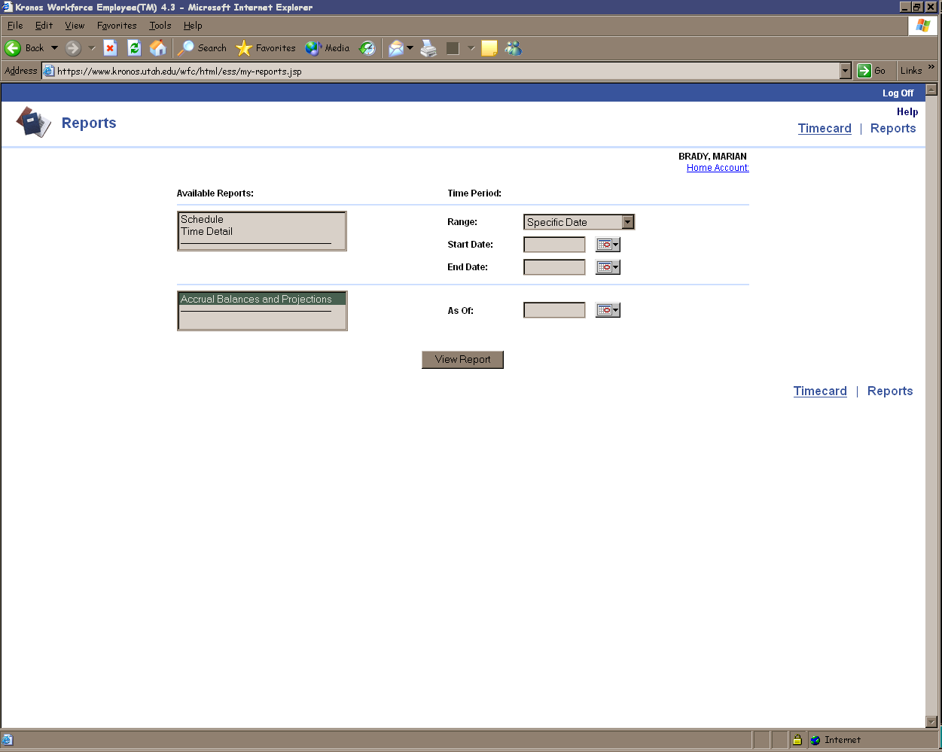
Schedule: Shows the schedule for the selected time frame.
Time Detail: Shows detail information about the hours worked for the selected time frame.
Calendar: Select date from a calendar
Range: Specify time frame.
View Report: Lets you view the report.
Accrual Balances and Projections: Shows accrual balances for the selected time frame.
lllllllllllllllllll

